Creating an item metadata template in DSpace



1. Log in to DSpace at http://www.dalnetarchive.org/.

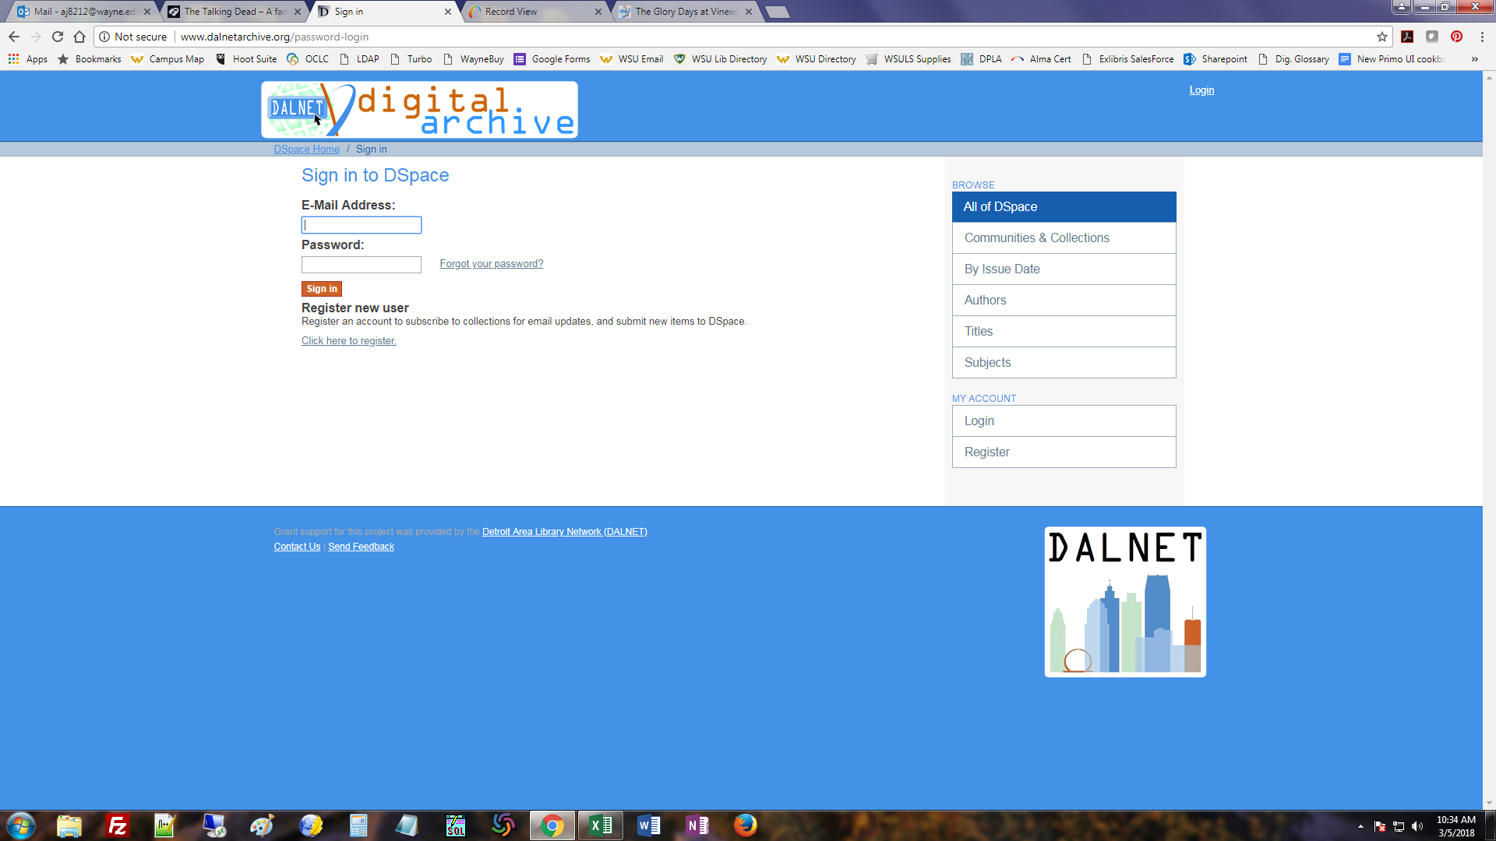

2. Click on your library’s community.

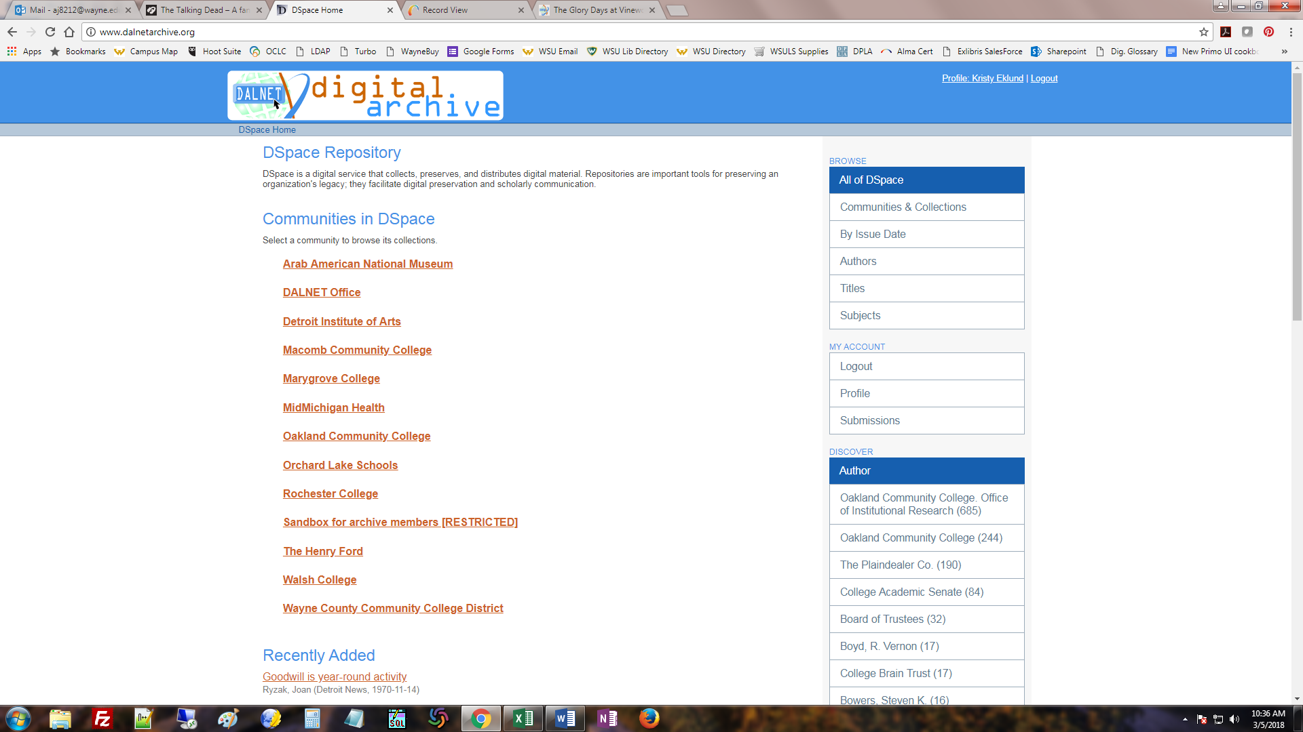

3. Choose collection you want to make the template for. You may have to click through a sub-community first to get to your collections (depending on how your DSpace has been set up).

Sub-community, then collection

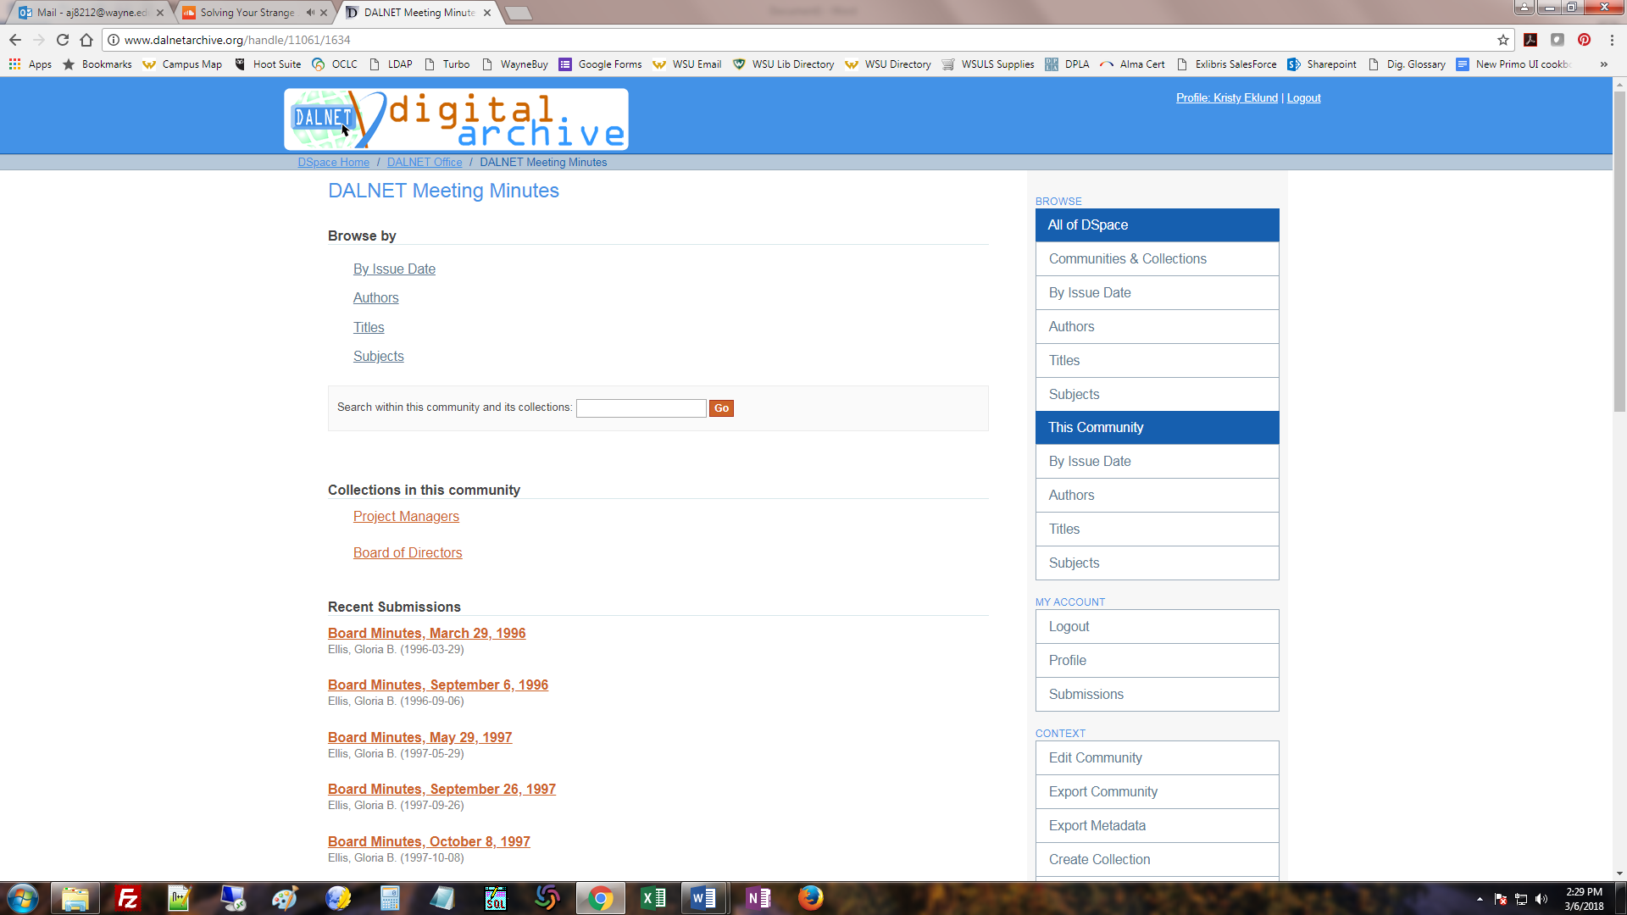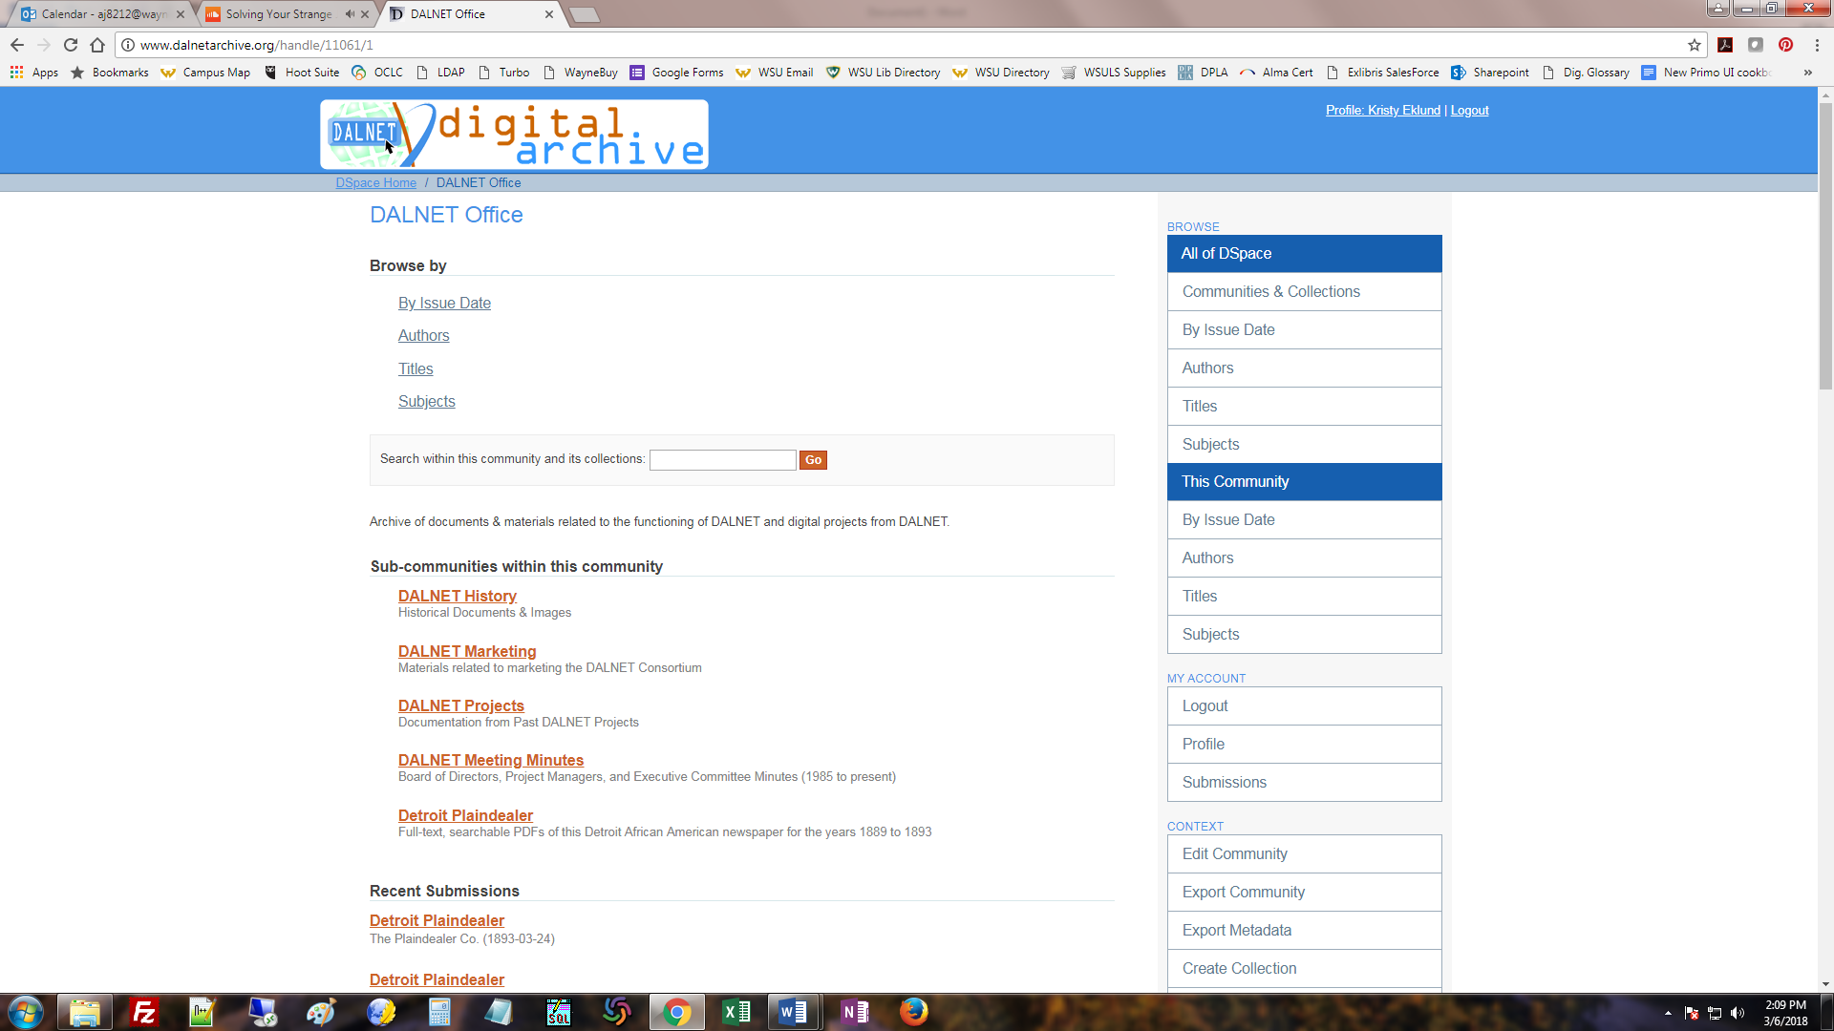

* or -

Collection

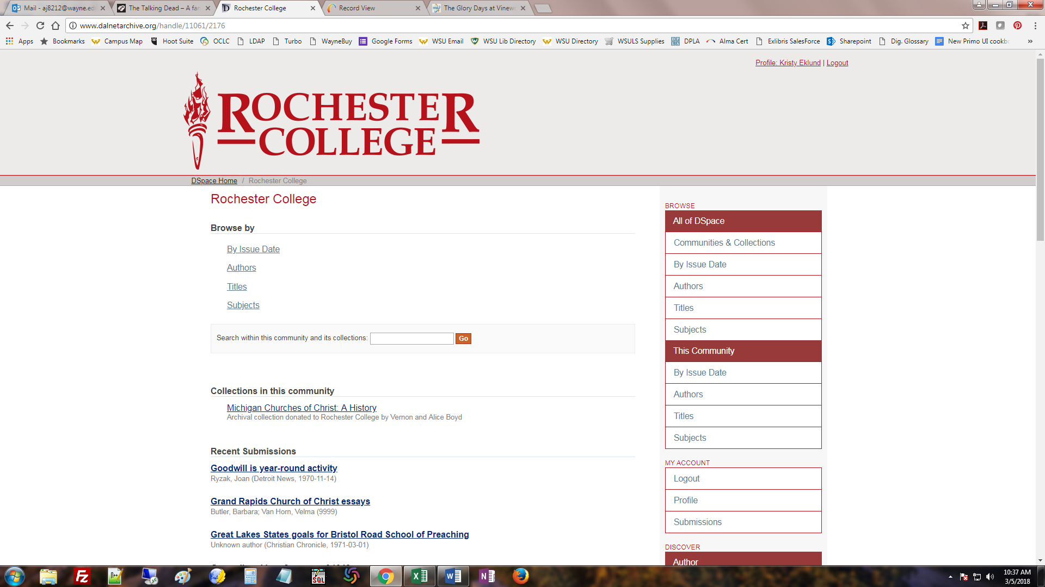

4. Once in a collection, click Edit Collection.

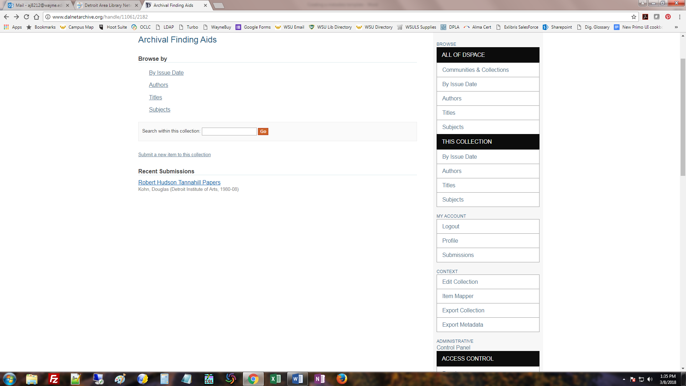

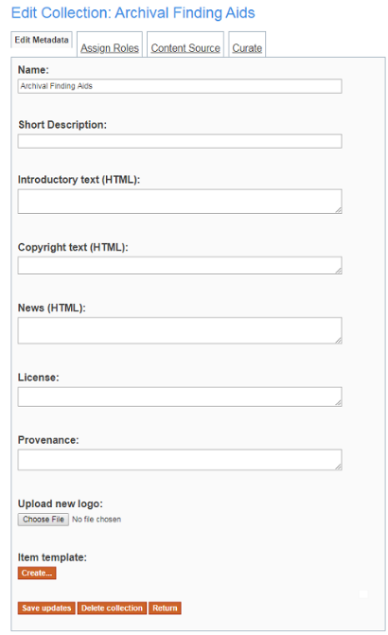5. On the Edit Collection screen, click the Create button under Item Template.

6. Click the drop-down to see the Dublin Core metadata fields available to add to the default item template (see note below for the fields included in the default template). If you want to pre-fill a field with data (e.g. a subject heading that applies to every item in the collection), you can enter this in the Value field and click Add New Metadata. Repeat as needed.

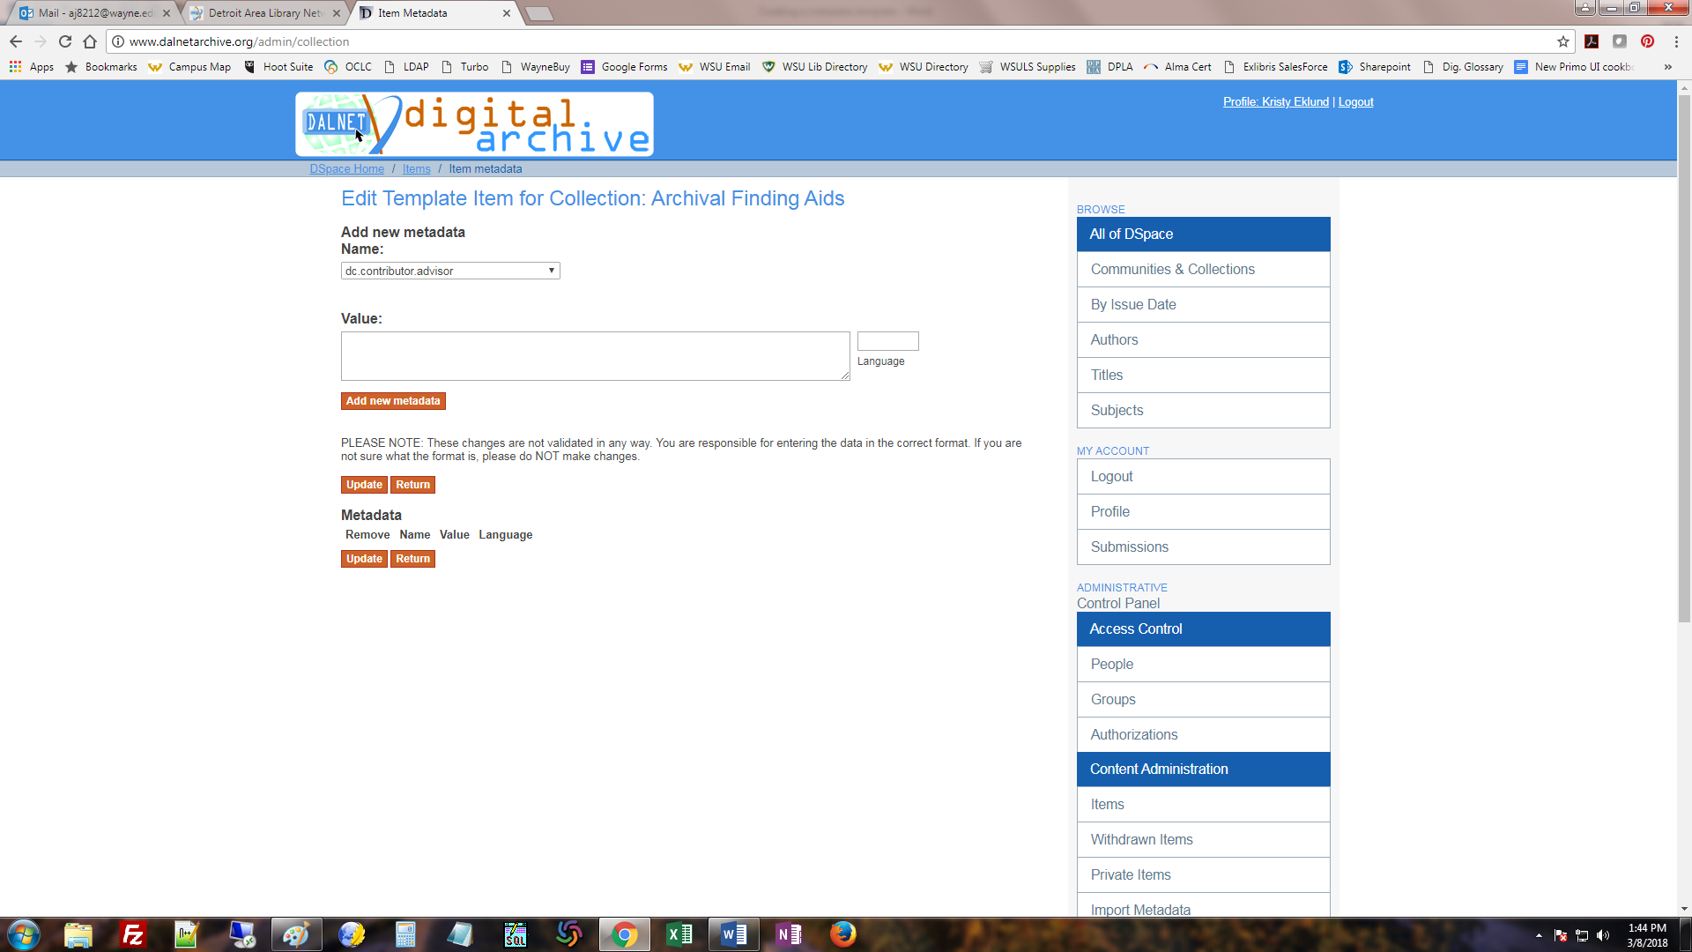

When you are done, click Return.

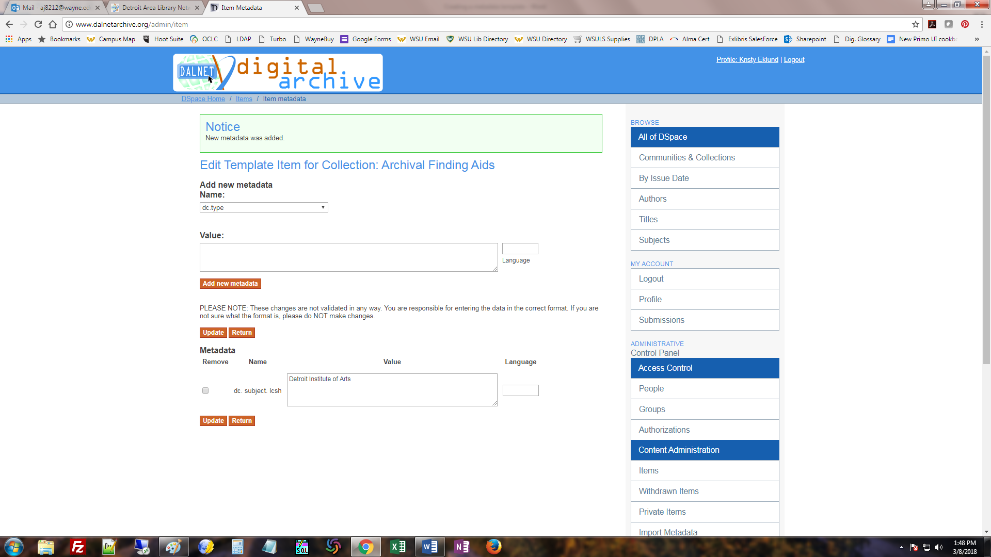

Note:

The default Item Template already contains these fields (unless you specified something different on your paperwork):

* Authors
* Title
* Other Titles
* Date of issue
* Publisher
* Citation
* Series/Report no.
* Identifiers
* Type
* Language
* Subject keywords
* Abstract
* Sponsors
* Description

When adding an item, you have to fill in at least the Title field and then Date of Issue: Year field to be able to save/go on to the next page. The other fields are optional.

kae3/2018